**Name**:___________________________ **Date**:______________

**Year & Block**: _____________________ **Score**: ______________

**Laboratory Activity 2**

**Instructions:**

1. Create a new script file named sysinfo.sh.
2. Inside the script, include commands that will:
   * Display the current **username**
   * Display the **hostname** of the computer
   * Display the **present working directory**
   * Display the **current date and time**
   * Display the **network configuration** of the system

Expected Output

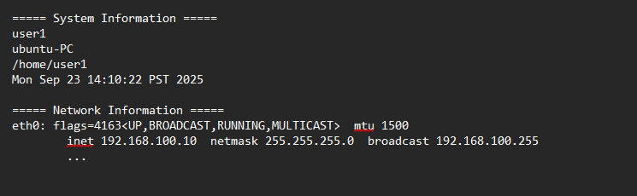

|  |  |
| --- | --- |
| Your Script (Screenshot) | Your Output (Screenshot) |
|  |  |